COMP 3711
Lab 4
October 4 - 8

Solution

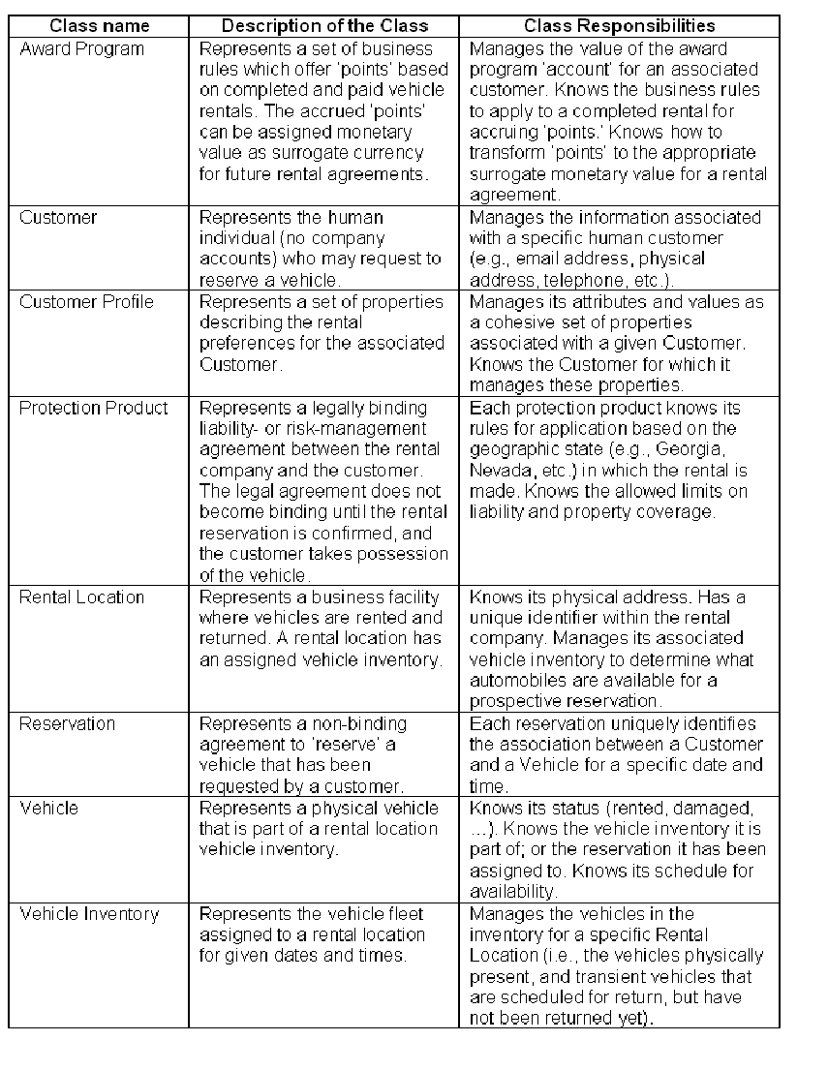

The rest of the solution is in the Rose model.

